Name: |  | Class:
Centre Number: |  | Index Number:
DUNMAN HIGH SCHOOL
PRELIMINARY EXAMINATION
YEAR 6



_________________________________________________________________________

HIGHER 2 GEOGRAPHY 9173/01
Paper 1

INSERT
_________________________________________________________________________

READ THESE INSTRUCTIONS FIRST

This insert contains all the Resources referred to in the questions.

This document consists of 9 printed pages and 1 blank page.
[Turn over

Resource 1 for Question 1
Distribution of hydroelectric power stations in Scotland, UK
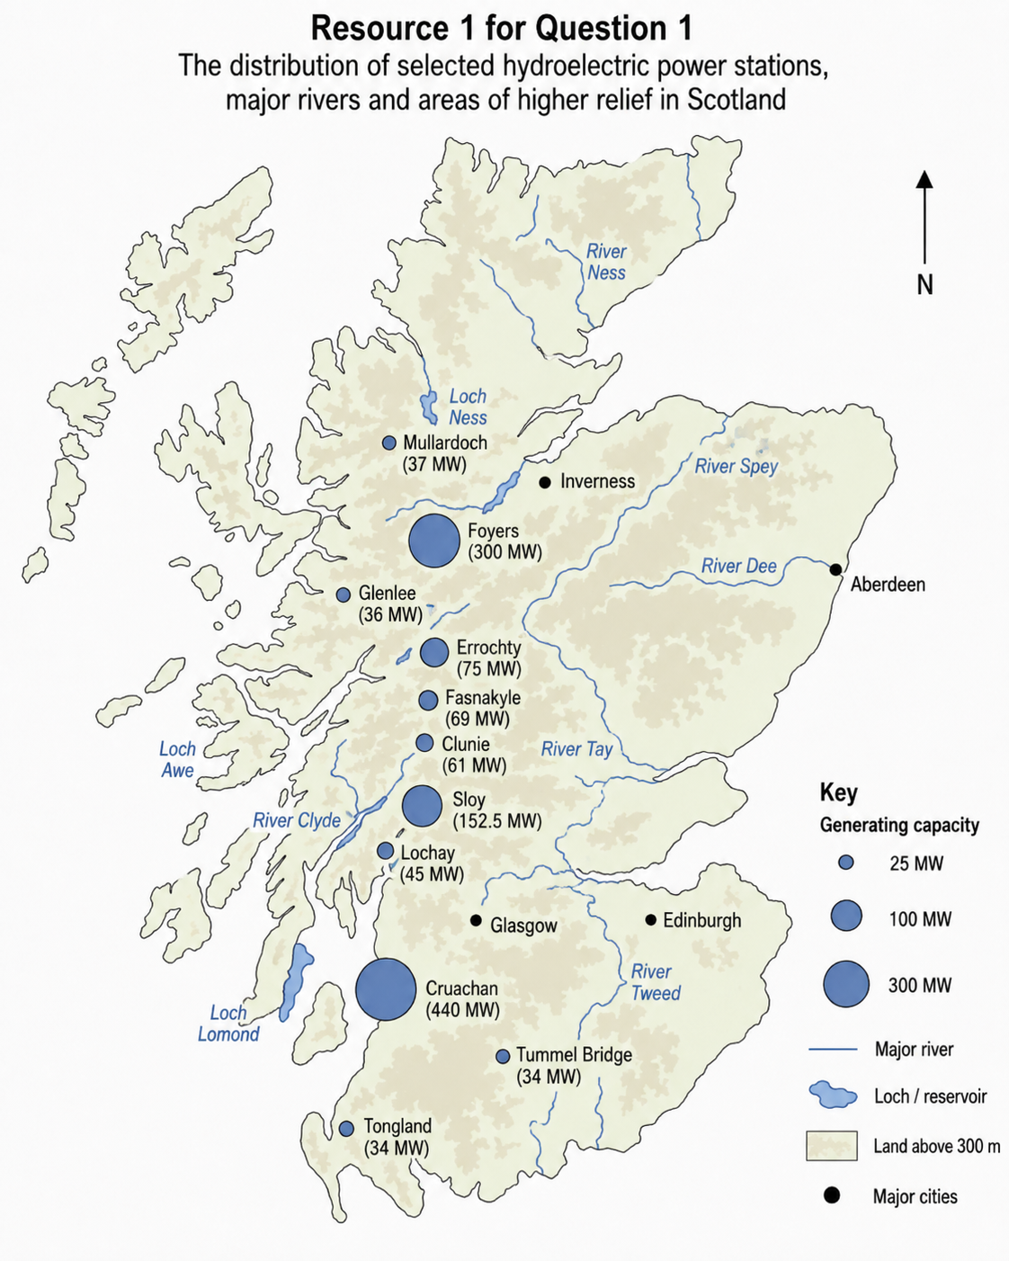

Resource 2 for Question 1
Sources of electricity generation in Scotland, UK from 2010 to 2020
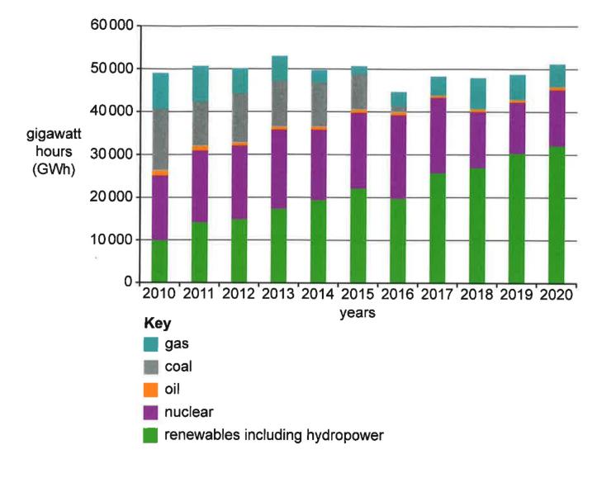

Resource 3 for Question 1
GPN of DJI in 2006
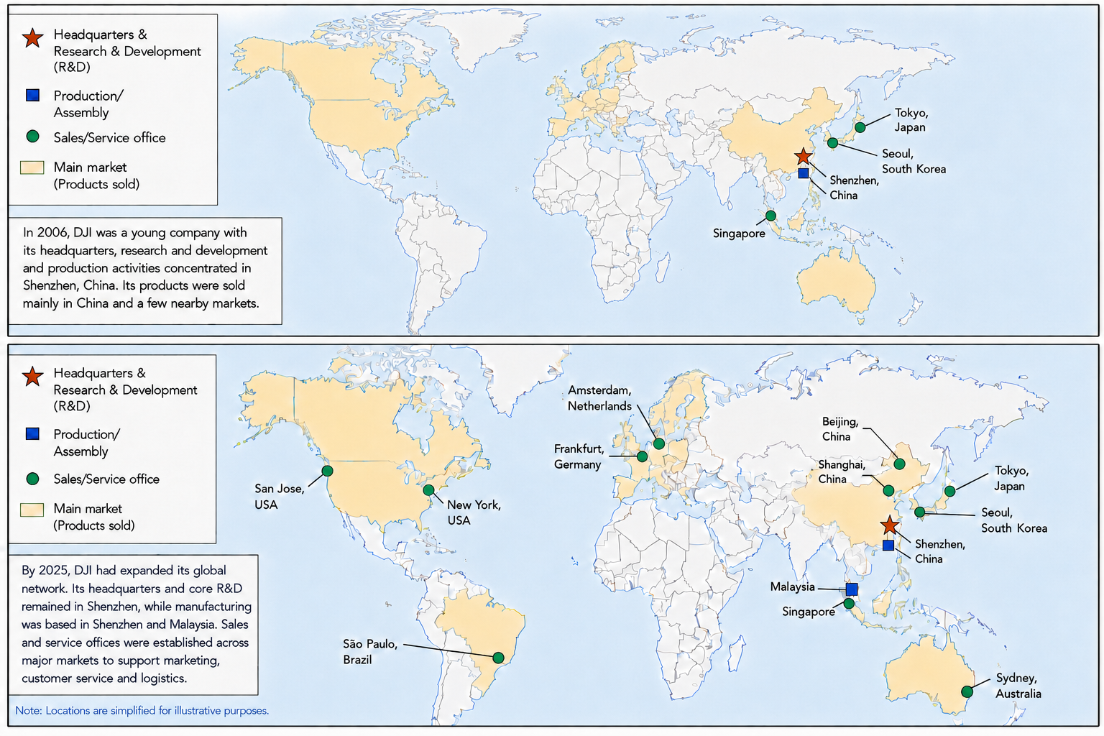
GPN of DJI in 2025

Resource 4 for Question 1
Impact of DJI’s GPN on USA in 2023
DJI-related activity | Direct jobs | Total jobs* supported | Wages and benefits generated  (US dollar) | Economic output generated  (US dollar)
DJI’s direct operations in USA | 119 | 482 | 46.3 million | 166.4 million
DJI’s purchase of goods and services from USA suppliers | 213 | 516 | 40.5 million | 109.0 million
Distribution and sale of  DJI products through distributors/retailers  for USA consumers | 2,012 | 4,159 | 271.5 million | 714.2 million
Commercial use of DJI products by USA businesses** | 140,143 | 459,523 | 38.8 billion | 115.9 billion
* Total jobs supported include direct and indirect employment.
** Businesses across US industries such as agriculture, construction, filmmaking, surveying, utilities and emergency services use DJI drones to perform tasks more efficiently, safely and at lower cost.
DJI-related activities generated approximately US$12.1 billion in national, state and local business taxes.

Resource 5 for Question 2
Forecasted likelihood of the three El Niño Southern Oscillation (ENSO) phases -
La Niña, Neutral, El Niño, from February to December 2024
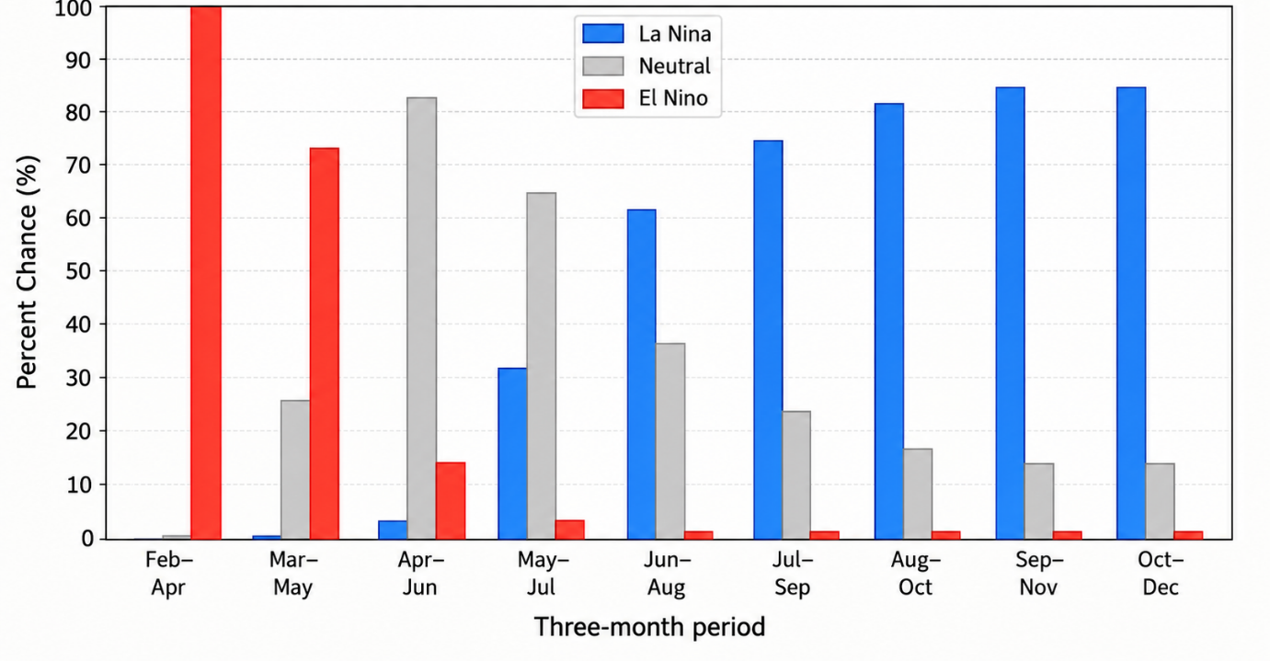

Resource 6 for Question 2
La Niña climate impacts from December 2023 to February 2024
and from June 2024 to August 2024
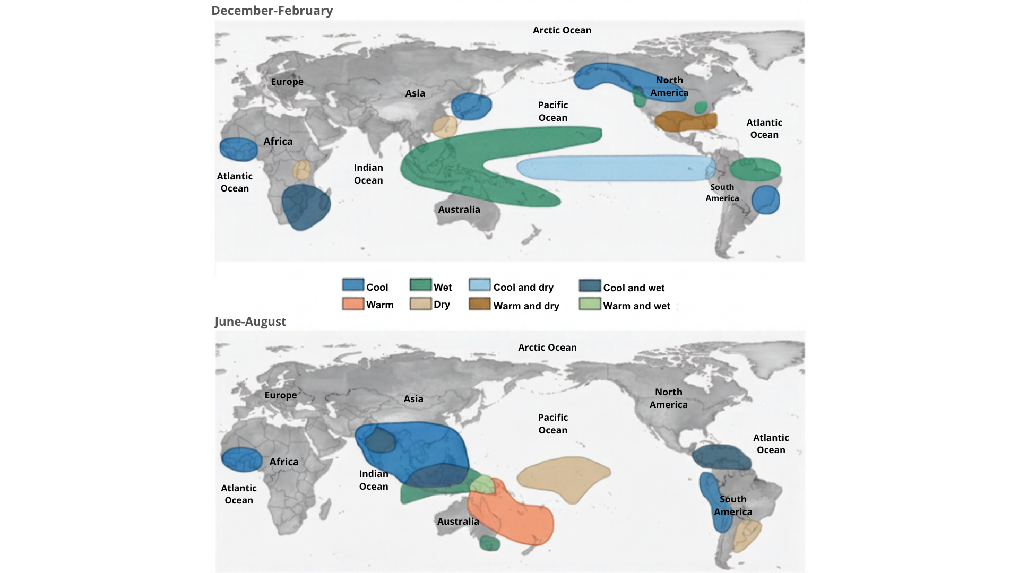
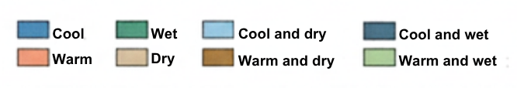

Resource 7A for Question 2
Satellite image of Yellow River Delta in Shandong Province, China, in 1979
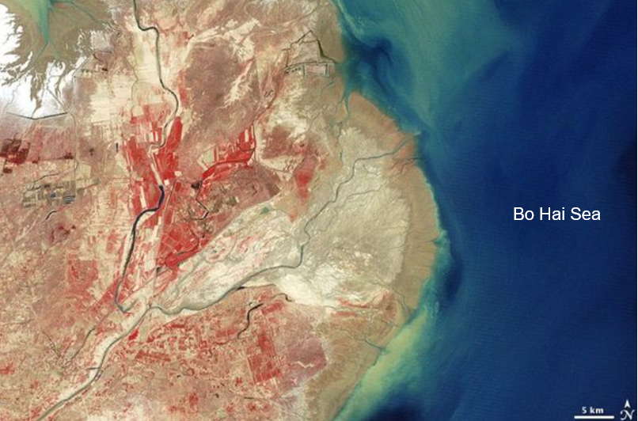
Resource 7B for Question 2
Satellite image of Yellow River Delta in Shandong Province, China, in 2000
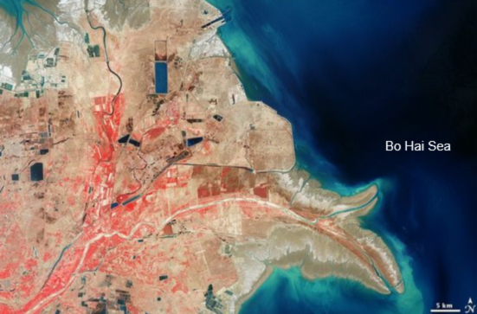

Resource 8 for Question 2
Annual discharge, annual sediment load and land area of delta
of the Yellow River in Shandong Province, China, between 1979 and 2020
Year | Annual  discharge  (billion m³) | Annual  sediment load  (million tonnes) | Land area  of delta  (km²)
1979 | 29.6 | 714 | 2690
1990 | 12.0 | 314 | 3038
2020 | 19.0 | 199 | 2893

___________________________________________________________________________________________________________________

Copyright Acknowledgements
Question 1 | Resource 1 | Constructed for educational purposes using publicly available information on selected hydroelectric power stations in Scotland.
Question 1 | Resource 2 | Singapore Examinations and Assessment Board (2024), GCE A-Level Geography, Syllabus 9751, Paper 1.
Question 1 | Resource 3 | Compiled from DJI, “About Us”, https://www.dji.com/company
Question 1 | Resource 4 | Adapted from John Dunham & Associates (2023), 2023 Economic Impact of DJI: Methodology and Documentation, prepared for DJI Technology.
Question 2 | Resource 5 | https://www.climate.gov/news-features/blogs/enso/march-2024-enso-update-award-season
Question 2 | Resource 6 | https://www.climate.gov/news-features/featured-images/global-impacts-el-ni%C3%B1o-and-la-ni%C3%B1a
Question 2 | Resource 7 | https://science.nasa.gov/earth/earth-observatory/yellow-river-delta-china-36236/
Question 2 | Resource 8 | Li et al. (2021), Remote Sensing 13, 4789; Wang et al. (2010), Journal of Hydrology 391, 302–313.

BLANK PAGE

